traxis User Guide

# 1 Dependencies

Before the traxis application can be run the following dependencies need to be installed:

## 1.1 Python 3 (3.3+ recommended)

### 1.1.1 Windows

Python 3 can easily be installed using the official binaries at <https://www.python.org/downloads/windows/>. Download the “Windows x86 MSI installer” and follow the instructions to install Python 3. During installation, the user can customize the features that can be installed. Ensure that the option to “Add python.exe to Path” is selected.

### 1.1.2 Mac

To install Python 3 on Mac, the simplest method is to use “Homebrew”, a package manager. Instructions to install “Homebrew” are available at <http://brew.sh/>. Once this has been installed, type the following command into the terminal to install Python 3:

brew install python3

brew tap Homebrew/python

brew install scipy –with-python3

The last step may take a while.

### 1.1.3 Linux

If your OS is reasonably up to date it is likely that Python 3 is already installed.

To install on openSUSE:

sudo zypper install python3

If you are using another Linux distribution the package name may be different (e.g. python33) so please consult your package manager.

## 1.2 PyQt 5 (5.3+)

### 1.2.1 Windows

The installation binary for PyQt5 can be obtained from <http://www.riverbankcomputing.com/software/pyqt/download5>. Download the “PyQt5-5.3.2-gpl-Py3.4-Qt5.3.1-x32.exe” binary and follow the instructions to install PyQt5.

Note: the version numbers in the downloaded PyQt5 .exe should reflect the current version of PyQt5 and your version of Python 3.

### 1.2.2 Mac

See instructions in Section 1.1.2 to install Homebrew. To install PyQt5 on Mac, type the following command into the terminal:

brew install pyqt5

Homebrew will install any required dependencies for the package.

### 1.2.3 Linux

To install on openSUSE, for example, first you must add the Python-3 modules repository:

sudo zypper ar -f http://download.opensuse.org/repositories/devel:/languages:/python3/openSUSE_13.2/

where 13.2 should be replaced by your version of openSUSE. The repository containing PyQt5 will be different for other distributions.

Next, install the PyQt5 package:

sudo zypper install python3-qt5

The name of the package may be different on other distributions (e.g. python3-pyqt5).

## 1.3 numpy and scipy

### 1.3.1 Windows

As scipy is dependent on numpy, install numpy first. Download the “numpy-1.9.1-win32-superpack-python3.4.exe” binary from <http://sourceforge.net/projects/numpy/files/NumPy/1.9.1/> and follow the installer instructions.

For scipy, download the “scipy-0.14.0-win32-superpack-python3.4.exe” binary from <http://sourceforge.net/projects/scipy/files/scipy/0.14.0/> and follow installer instructions.

If either installer displays an error message about not finding Python 3 after the user has installed it, then the Python directory has not been added to the PATH environment variable. Please reinstall Python 3 using the instructions described in Section 1.1.1. Note: replace the version numbers in the links and files stated above with the appropriate versions of numpy, scipy and Python 3.

### 1.3.2 Mac

Numpy and scipy can be installed with pip3, which should have been installed along with Python 3 (3.4+). However, if pip3 is unavailable, please follow the instructions at <https://pip.readthedocs.org/en/latest/installing.html>.

Type the following commands into the terminal to install numpy and scipy:

pip3 install numpy

pip3 install scipy

### 1.3.3 Linux

The easiest way to install these Python packages is using pip. If you are using Python 3.4+, then pip should already be installed. If it is not, then it can either be installed via your package manager (e.g. on openSUSE: sudo zypper install python3-pip) or alternatively by following the instructions on this webpage: <https://pip.readthedocs.org/en/latest/installing.html>.

Once pip for Python 3 is installed, numpy and scipy can be installed by issuing the following commands in a terminal window:

pip3 install numpy

pip3 install scipy

These packages could alternatively be installed via your OS’s package manager. For example, on openSUSE scipy can be installed as follows (if the Python-3 modules repository has been added; see Section 1.2.3):

sudo zypper install python3-scipy

# 2 Installation

The traxis application does not need to be installed. Simply download the source and extract the files.

On Linux/UNIX/Mac OS X:

1. Download traxis-1.0.0.tar.gz
2. Open a terminal and go to the directory containing traxis-1.0.0.tar.gz
3. Execute tar xzvf traxis-1.0.0.tar.gz
4. Change into the newly created directory: cd traxis-1.0.0/
5. Start the application by executing ./runtraxis

If using a Mac and Python 3 fails to import PyQt5, type the following command:

export PYTHONPATH=/usr/local/lib/python3.4/site-packages:$PYTHONPATH

and rerun the command to start the application. If Python 3 has been installed at some other location, modify the path in the command above as appropriate.

On Windows:

1. Download traxis-1.0.0.zip
2. Extract the zip file. The extracted contents will be contained in a folder named “traxis-1.0.0”
3. Open a command prompt
4. Change into the traxis-1.0.0 directory: cd path\to\traxis-1.0.0\ where path\to\ should be replaced by the location of the traxis-1.0.0 directory.
5. To start the application, execute python3 runtraxis or python runtraxis (or any other appropriate command), depending on your alias for the Python 3 executable.

# 3 Starting Up

## 3.1 UI Components

After starting up the application (see Section 2) the application GUI will be opened (Figure 1).

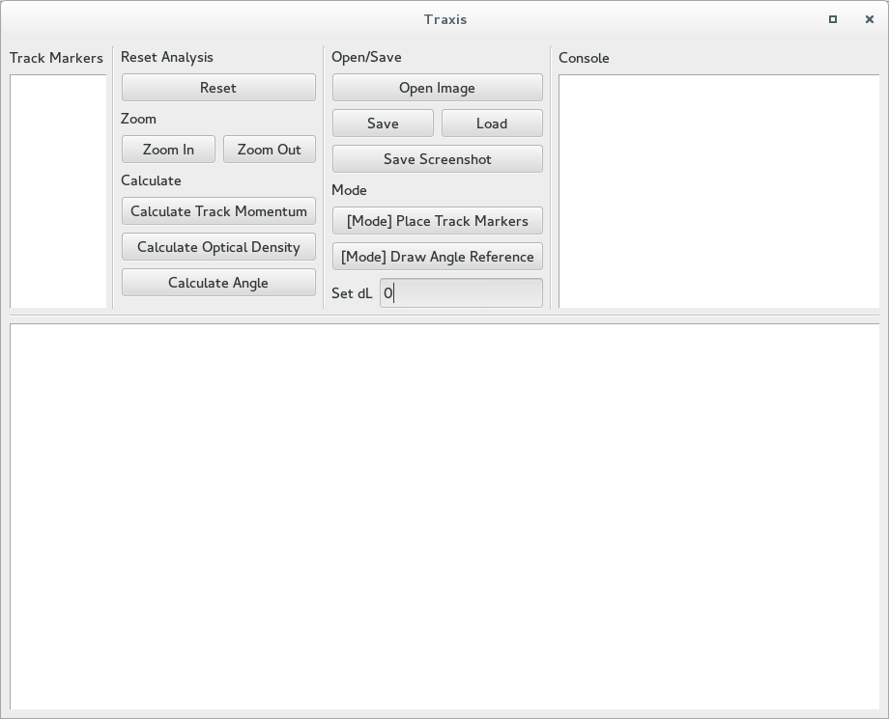

Figure 1 - the traxis GUI on startup

The top half of the GUI has three components: a list of “Track Markers” (see Section 4.1), a Console where the application will display various messages to the user in response to user actions, and a set of buttons and a text input box which allow the user to enter information and to execute actions.

The bottom half of the GUI contains an Image Viewer where the image being analyzed is displayed. Once an image is opened (Section 3.2), depending on the selected mode, clicking on the image loaded in the Image Viewer will either allow the user to pan the image, to place Track Markers on the image (Section 4.1) or to draw an angle reference line (Section 4.2).

## 3.2 Opening an Image

To open an image, click `Open Image` or press ‘O’. A file dialog will open from which the file system can be browsed for an appropriate image file (e.g. .png). After selecting a file and clicking `Open`, the image will be displayed within the Image Viewer, scaled down such that the entire image fits within the Image Viewer (but without any loss in resolution).

Alternatively, if a session was previously saved, it can be loaded by clicking `Load` and the image that was being analyzed in that session will be re-opened. Saving and Loading will be discussed in Section 5.

## 3.3 Image Manipulation

After an image has been opened, clicking `Zoom Out` (or pressing ‘Z’) will zoom into the image at the location where it is currently centered in the Image Viewer. Clicking `Zoom Out` (or pressing ‘X’) will zoom out.

After zooming in, scroll bars will appear in the Image Viewer and it will be possible to scroll around the image by clicking on the scroll bars, by pressing the arrows keys (if the Image Viewer has focus) or by clicking and dragging on the picture if not in either the “Place Tracker Markers” or “Draw Angle Reference” mode.

# 4 Analysis

## 4.1 Track Momentum

Once an image has been opened, enter Track Marker placement mode by clicking `[Mode] Place Track Markers` or by pressing ‘P’. Track markers can then be placed by simply clicking on the image.

It is recommended that users zoom into the image in order to accurately place the markers. That said, a marker can be moved after being placed onto the image. To do so, select the desired marker from the list of point names or press ‘F’ and ‘V’ to scroll through the points. Note that the selected point will be highlighted as a yellow marker. To move the point up, down, left or right, press ‘W’, ‘S’, ‘A’ or ‘D’, respectively. To do coarse movement, hold ‘Shift’ while pressing the appropriate key to move the marker.

The start and end Track Markers need to be specified before fitting. Select the desired marker as mentioned above and press ‘G’ or ‘H’ to designate the marker as the start or end point, respectively. Note that the selected start (end) marker will be coloured blue (green) and its name will be prepended with a ‘s - ‘ (‘e - ‘) in the list of Track Markers. If another point is desired to be chosen as the start/end point, select the new point and press the appropriate key.

If a point is desired to be deleted, select that point and press ‘Delete’ (or ‘fn + delete’ on a Mac).

Finally, click `Calculate Track Momentum` or press ‘M’ to fit a circle to the placed markers. Upon fitting, an arc from the chosen starting point to the end point will be drawn and the track momentum will be printed to the console. If the wrong arc is drawn, simply reverse the designated start and end points of the track and recalculate the track momentum.

## 4.2 Optical Density

To calculate optical density, track momentum must be calculated first (see Section 4.1).

Optical density is calculated by summing up the blackness[1] of the pixels in a bounded area. To select the area, change the dL parameter in the “Set dL” text box. This will create a region around the fitted arc by varying the radius by +/- dL. Ensure that the track bubbles are contained within this selected region; if this is difficult to do, move the selected points as mentioned in Section 4.1 and refit the track. Press ‘Tab’ after a value for dL has been set. This is to ensure to that other keyboard presses are registered by the software instead of being sent to the text box.

Finally, click `Calculate Optical Density` or press ‘N’ to estimate the optical density.

## 4.3 Opening Angle

To calculate opening angle, track momentum must be calculated first (see Section 4.1).

Opening angle is given as the angle between the tangent at the selected start point and a reference line. To draw the reference, first click `[Mode] Draw Angle Reference` or press ‘L’. Then simply click and drag on the image to draw a reference line. If the line is incorrectly drawn, simply redraw the line by clicking a dragging again. To remove the reference line altogether, simply click and release the mouse without dragging while in the Draw Angle Reference Mode.

Finally, click `Calculate Angle` or press ‘B’ to estimate the opening angle of the track. Note that since the underlying software takes into account the directions of the tangent and reference lines, for a true opening angle of $θ$, the angle might be measured as $θ$, $180-θ$, $180+θ$ or $360-θ$. Visually inspect the image and appropriately modify the measured angle.

## 4.4 Resetting

At any time the user can click `Reset` or press ‘R’ and the image will be rescaled to the size it was when first opened. Anything drawn on the image will be removed, dL will be reset to 0, the console will be cleared and the list of point trackers will be emptied.

# 5 Saving and Loading

## 5.1 Saving a Session

In order to save a session, an image must first be opened. When clicking `Save`, a save file dialog will be opened in which the filename and the location where the data is saved can be selected. Session data will be saved in JSON format so the .json extension should be used.

The data that is saved in the .json file will be the file location of the opened image (and so if the image is moved the saved data cannot be loaded afterward), the coordinates of any placed Track Markers, which of the Track Markers have been designated as the start and/or end points (if any), the dL (if not 0) and the start and end points of the reference line if one has been drawn.

The JSON file can be read into MATLAB or Python for any further analysis. It can also be converted to CSV format using websites such as https://json-csv.com/.

## 5.2 Loading a Session

To load a saved session, click `Load` and a file dialog will be opened. Select the .json file containing the saved session data and click Open. If the image in the saved session has been moved since saving, the saved data will not load.

Once the .json file has been opened, the loaded image will be scaled to fit within the Image Viewer and, depending on whether other data had been saved, Track Markers will be drawn on the image, the start and end points will be set as such, the dL value will be set and the reference line will be drawn

## 5.3 Saving a Screenshot

To save what is currently visible within the Image Viewer (including everything that is drawn on that portion of the image), click `Save Screenshot`. A save file dialog will open in which the file name and save location of the screenshot can be selected. The contents of the currently visible portion of the Image Viewer will be saved in the selected file.

# 

# Appendix A - Keyboard shortcuts

|  |  |
| --- | --- |
| **Key** | **Function** |
| Up, Down, Left, Right | Moves the picture in the selected direction (if the Image Viewer has focus) |
| Z | Zooms into the picture |
| X | Zooms out of the picture |
| W, A, S, D (Shift+) | Moves the chosen point by 1 pixel in the selected direction. If shift is held while pressing the key, a coarse movement is performed. |
| F / V | Moves Up/Down on the “Track Markers” List |
| Delete (Fn + delete on Mac) | Deletes the selected point |
| G | Marks the chosen point as the start of the track |
| H | Marks the chosen point as the end of the track |
| M | Fits a circle to the points and calculates momentum |
| N | Calculates Optical density |
| B | Calculates Opening angle |
| P | Enters/exits the “Place Track Markers” mode |
| L | Enters/exits the “Draw Angle Reference” mode. |
| O | Opens a dialog box to choose the picture to load |
| R | Resets the application |

1. As given in the CMKY colour units